07. February 2017

Contact specialized press
Margit Köhler
Communication Manager
Silica
Phone +49 6181 59-6335
margit.koehler@evonik.com

Evonik Resource Efficiency GmbH
Rellinghauser Straße 1-11
45128 Essen
Phone +49 201 177-01
Fax +49 201 177-3475
www.evonik.com

Supervisory Board
Dr. Ralph Sven Kaufmann, Chairman

Executive Board
Dr. Claus Rettig, Chairman
Dr. Johannes Ohmer,
Simone Hildmann,
Alexandra Schwarz

Registered Office: Essen
Register Court: Essen Local Court
Commercial Registry B 25783
VAT ID no. DE 815528487

Evonik presents Life Cycle Assessment of Silica/Silane technology for Green tires at Tire Technology Expo in Hanover

- The combined use of ULTRASIL® Silica and Evonik’s Silanes enable the production of Green tires
- Green tires with S-SBR rubber grades and Silica/Silane technology reduce fuel consumption by 5 %
- New LCA proves that 1.4 metric tons of CO₂ equivalents per 150,000 km driving distance are avoidable

Tires are high-tech composites, and the components of the treads have a huge impact on a tire’s performance. In comparison to conventional tires made of E-SBR rubber grade solely filled with carbon black, Green tires with S-SBR rubber grades and Silica/Silane technology have proven to have significantly lower rolling resistance, resulting in a reduction in fuel consumption by 5 % and thus lower CO2 emissions. Additionally, they also have better grip – particularly in wet conditions – while offering comparable durability.

The secret of success lies in the components’ interaction: Silica serves as active filler in the treads and ensure wear resistance in the tire, but is actually incompatible with S-SBR rubber grades. Evonik, one of the world’s leading producers of Silica and Silanes and the only company worldwide manufacturing and marketing both, solved this problem by adding Silane to chemically “couple” S-SBR rubber grades and Silica.

Next step: A Life Cycle Assessment
Green tires have already proven to have a significant impact on a vehicle’s total fuel consumption. The next logical step was to examine the potential environmental impact of tire treads based on Silica/Silane and S-SBR in Green tires in comparison to tire treads based on carbon black and E-SBR not only during the use phase, but from “Cradle to Grave”. To examine the environmental effects throughout the whole life cycle, Evonik has conducted a comprehensive Life Cycle Assessment (LCA), extending from the production of raw material to end-of-life.

The study analyzed impact categories such as the Global Warming Potential, the Photochemical Ozone Creation Potential, and the Primary Energy Demands. The functional unit was defined as the use of Silica/Silane and S-SBR in treads of passenger car tires over a driving distance of 150,000 km. Additionally, a sensitivity analysis was conducted with gasoline consumption, fuel savings, and lifetime as parameters.

Use phase is key to reduce emissions
According to the study, Silica/Silane technology in Green tires is able to significantly reduce emissions and environmental impacts in the basic scenario in any analyzed impact category considered relevant. Consequently, the Global Warming Potential can be reduced by 4.9 % in total over the whole life cycle; by replacing carbon black and E-SBR with Silica/Silane and S-SBR, emissions of up to 1.4 metric tons of CO₂ equivalents per 150,000 km driving distance are avoidable.

The study also shows that the use phase has a key impact on the overall lifecycle in all impact categories. As Green tires with Silica/Silane components can significantly reduce fuel consumption, this technology can have a key role in reducing emissions in general.

If you would like to learn more about Evonik’s Silica/Silane technology used in Green tires, we will be happy to welcome you at our booth, C816, at the Tire Technology Expo in Hanover between February 14 and 16.

Please visit our websites www.ULTRASIL.evonik.com and www.rubber-Silanes.com for additional information on Silica/Silane systems used in Green tires.

If you are interested in the study please follow this link:

Tires Go Green – A Life Cycle Assessment

http://ultrasil.evonik.com/sites/lists/RE/DocumentsSI/Tires-go-gree-a-life-cycle-assesment-EN.pdf

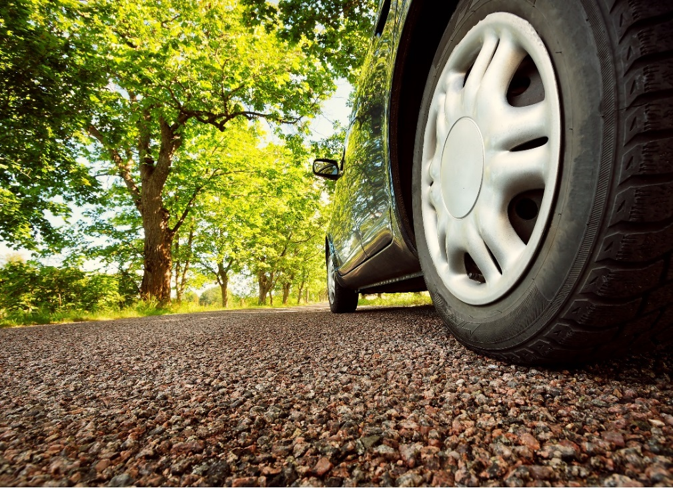

Company information
Evonik, the creative industrial group from Germany, is one of the world leaders in specialty chemicals, operating in the Nutrition & Care, Resource Efficiency and Performance Materials segments. The company benefits from its innovative prowess and integrated technology platforms. In 2015 more than 33,500 employees generated sales of around €13.5 billion and an operating profit (adjusted EBITDA) of about €2.47 billion.

About Resource Efficiency
The Resource Efficiency segment is led by Evonik Resource Efficiency GmbH and supplies high performance materials for environmentally friendly as well as energy-efficient systems to the automotive, paints & coatings, adhesives, construction, and many other industries. This segment employed about 8,600 employees, and generated sales of around €4.3 billion in 2015.

Disclaimer
In so far as forecasts or expectations are expressed in this press release or where our statements concern the future, these forecasts, expectations or statements may involve known or unknown risks and uncertainties. Actual results or developments may vary, depending on changes in the operating environment. Neither Evonik Industries AG nor its group companies assume an obligation to update the forecasts, expectations or statements contained in this release.

